Website changes

First I want to change the feel of the site with different color background etc. Posh uses a more upscale branding and while we want to be sophisticated in our branding we cater to different demographics. More friendly, lighter look. Cleaner color background. They have 2 different color mode, and we want a lighter color similar to the light mode on their site.

1. We are a membership club so all references to Subscription shall be changed to membership.

Landing page

I like this but we need a different background.

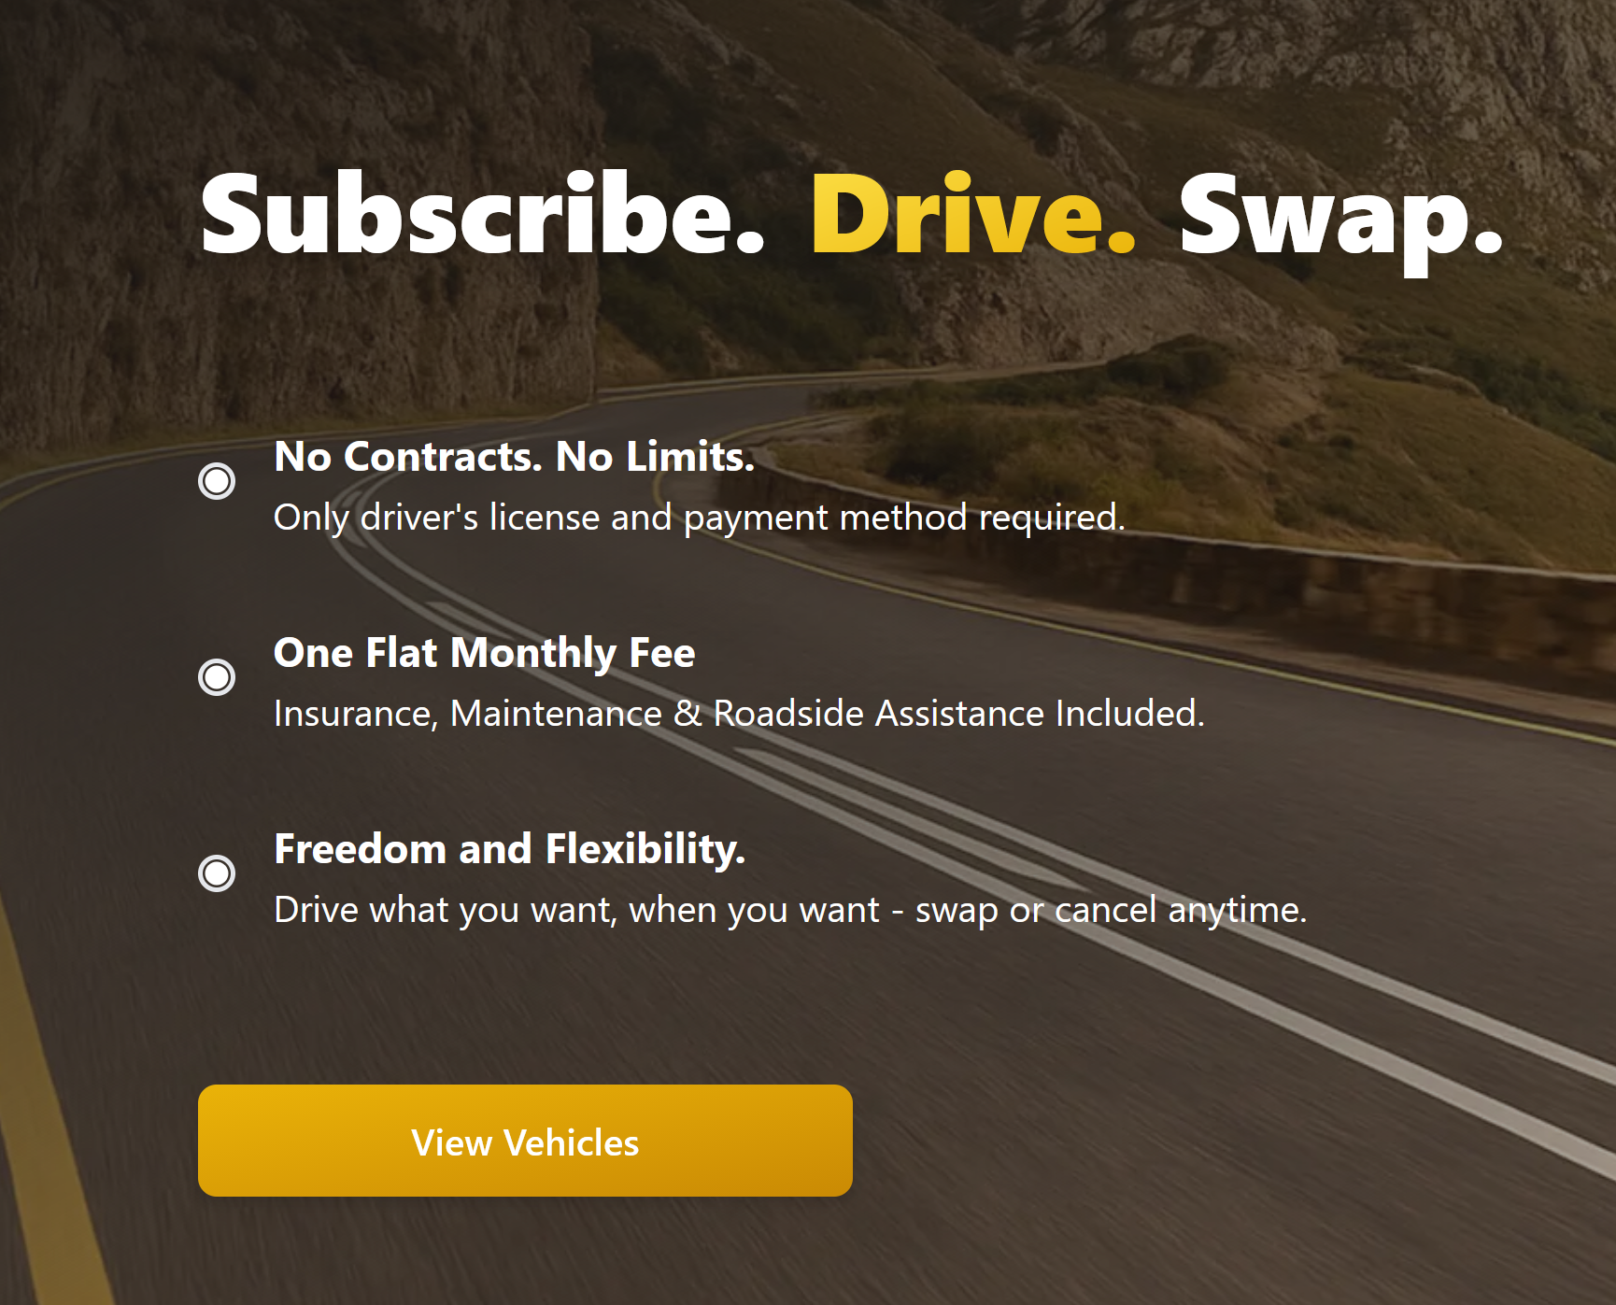

Maybe change the subscribe to Join

The One Flat Monthly fee we need to change as we have weekly dues.

1. We could change Pricing to Memberships.



1. We can delete the video

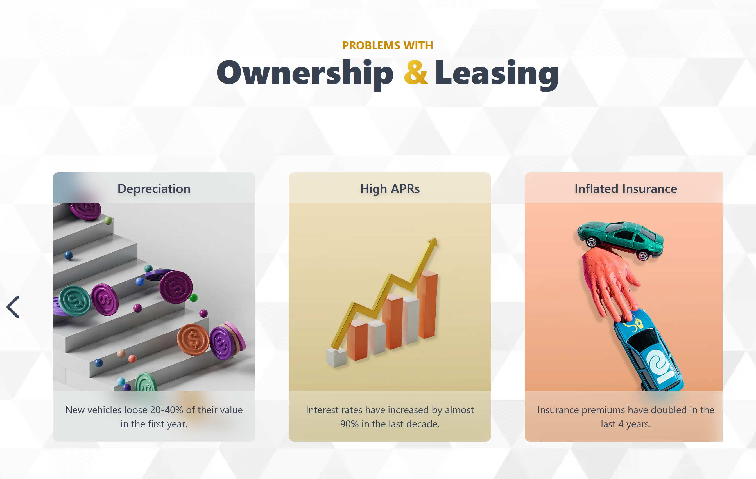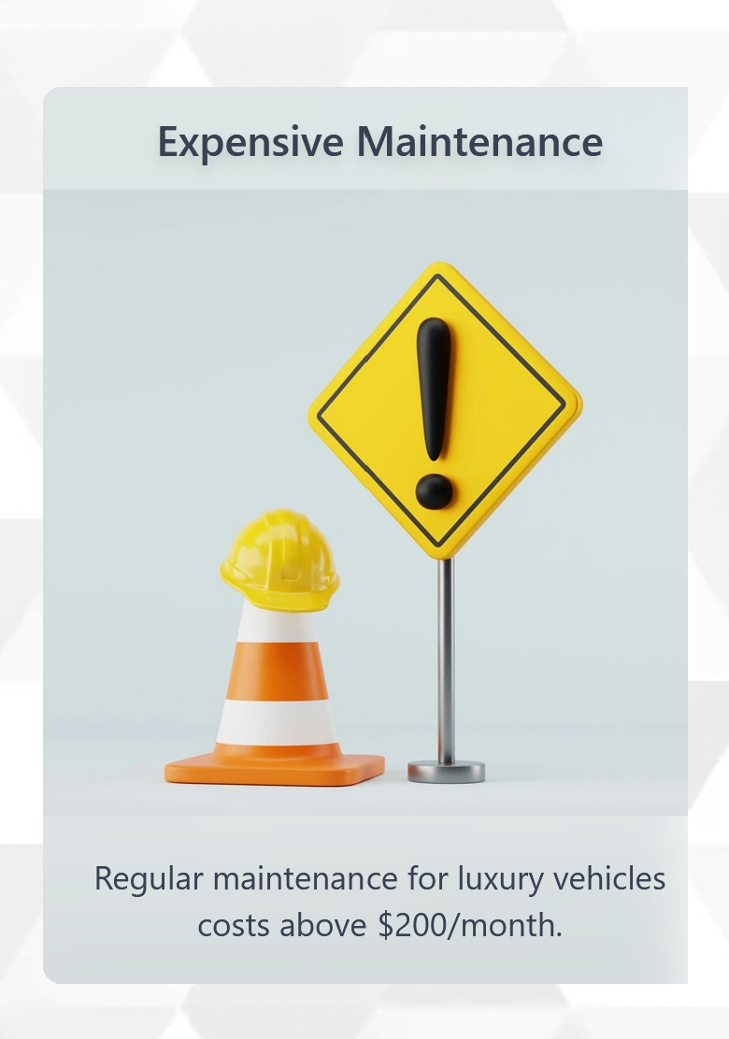

I think we need to change this to Problems with Buying & Leasing

1. I am not a fan of the pictures they selected and will find better ones.
2. Depreciation should read Vehicle Depreciation.
3. High APRS should say High Interest Rates.
4. Inflated Insurance should say Insurance Premiums
5. Expensive maintenance should add & repairs.

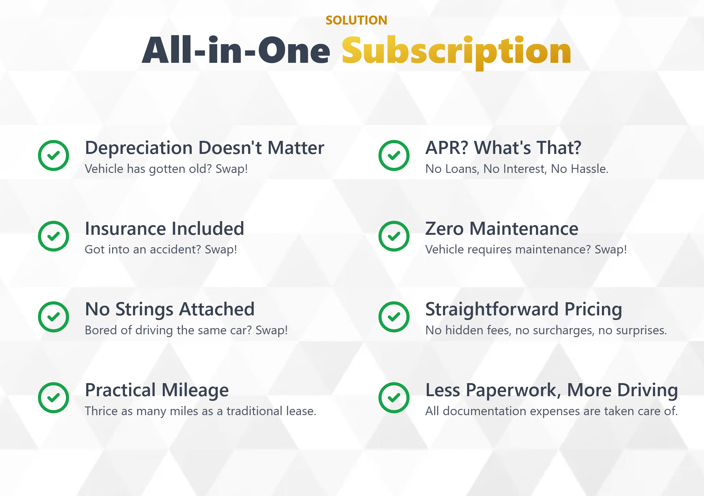

We need to change the headline to:

Zipsters The Smarter Solution

1. Depreciation Doesn’t Matter need to Change to:

Depreciation Losses

The average car depreciates 70-80% over the term of a loan leaving you car fairly worthless at the end of you loan.

1. Insurance Included

We have an option to include insurance.

1. No Strings attached need to change to Easy 5 minute deal.
   1. No Games No Gimmicks, No Application required
2. Practical Mileage changes to Unlimited Milage
   1. No Mileage restrictions to worry about.
3. APR? What’s That? Changes to High Interest Rates Eliminated.
   1. There is no interest charges with a Membership
4. Zero Maintenance will remain
   1. All routine maintenance covered at no charge.\*
   2. A repair program is available to cover mechanical problems.
5. Less Paperwork Less Hassle
   1. A simple 9 pages membership agreement is all the paperwork needed.



1. Subscription will change to Membership Plans

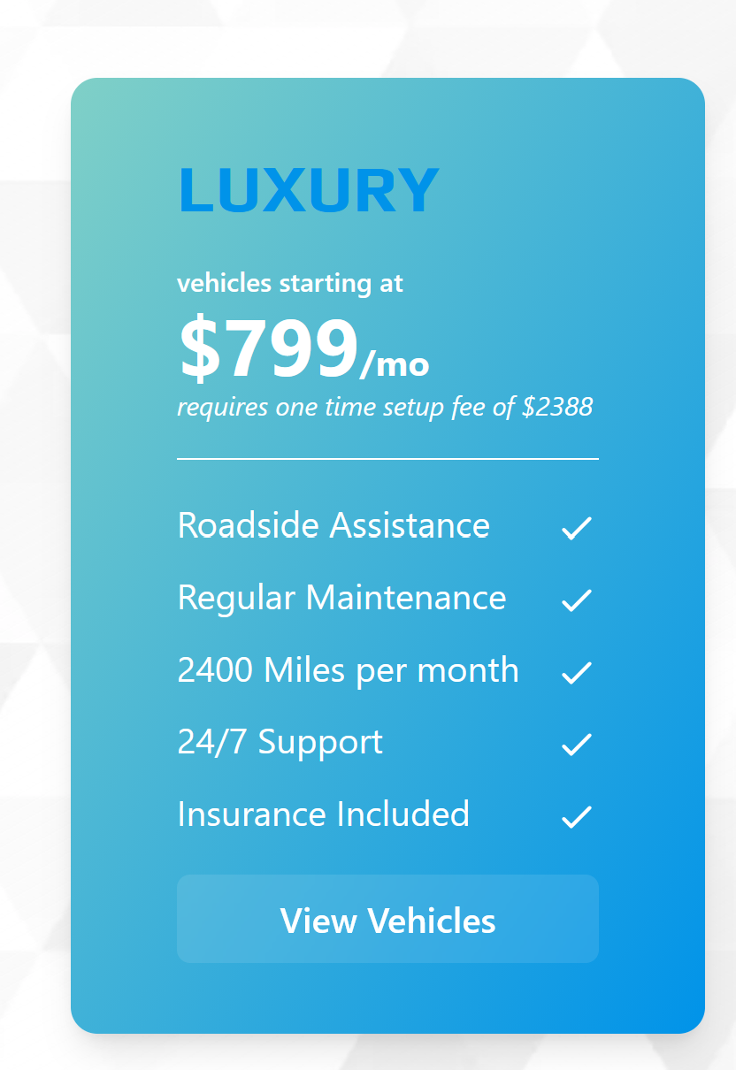

1. Luxury will Change to Silver.
   1. Vehicles starting at $799/mo will change to $125/week
   2. Requires a one time fee of $1000.00
   3. Roadside assistance will be deleted.
   4. Mile Per Month Unlimited
   5. Insurance included shall be Insurance available

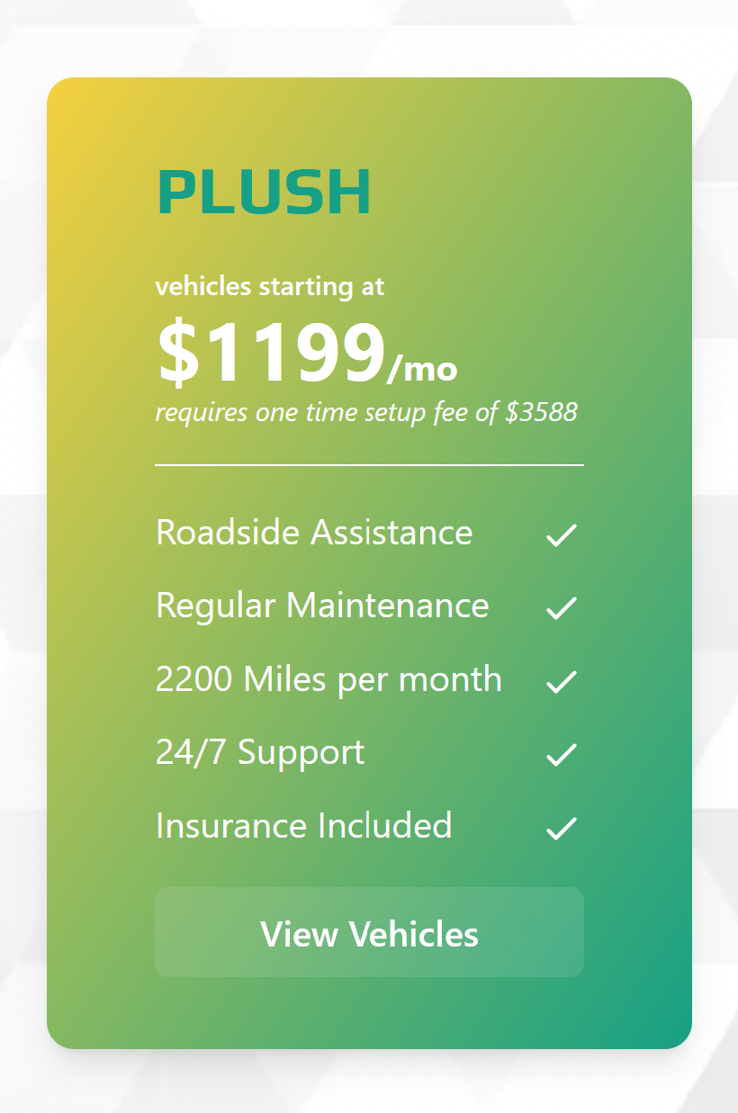

1. Plush will change to Gold.
   1. Vehicles starting at $1199/mo will change to $150/week
   2. Requires a one time fee of $1500.00
   3. Roadside assistance will be deleted.
   4. Mile Per Month Unlimited
   5. Insurance included shall be Insurance available

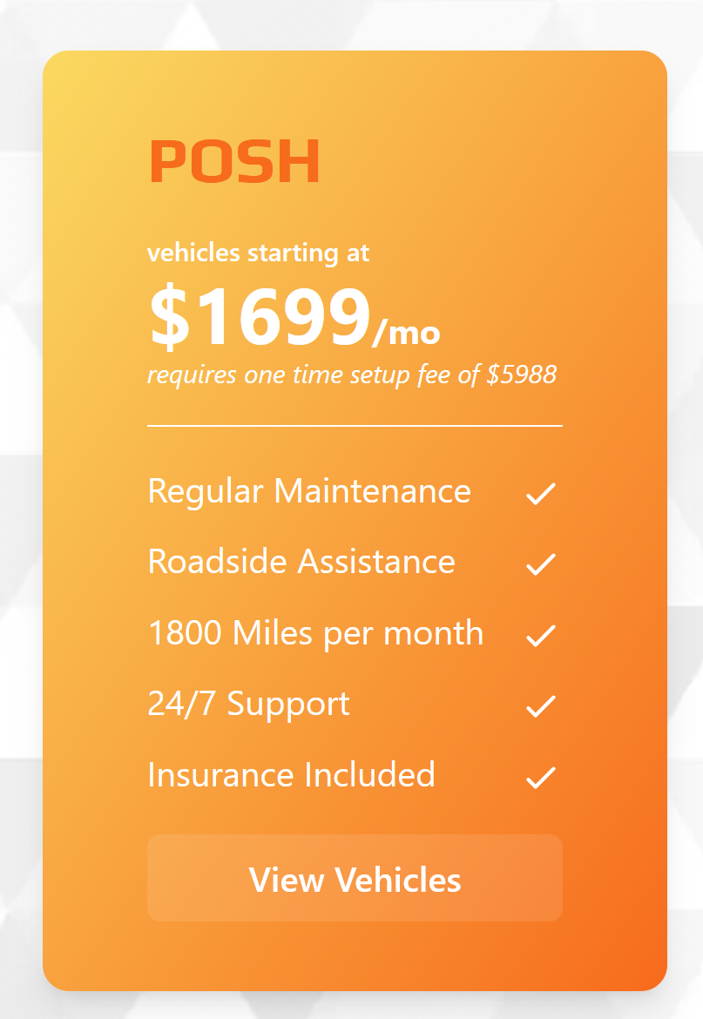

1. Posh will change to Platinum.
   1. Vehicles starting at $1699/mo will change to $200/week
   2. Requires a one time fee of $2000.00
   3. Roadside assistance will be deleted.
   4. Mile Per Month Unlimited
   5. Insurance included shall be Insurance available.

A New membership shall be added as Exotics

* 1. Vehicles starting at $250/week
  2. Requires a one time fee of $2500.00
  3. Roadside assistance will be deleted.
  4. Mile Per Month Unlimited
  5. Insurance included shall be Insurance available.



1. 4 Easy Steps will remain, but 4 Easy Steps and be below How it Works.

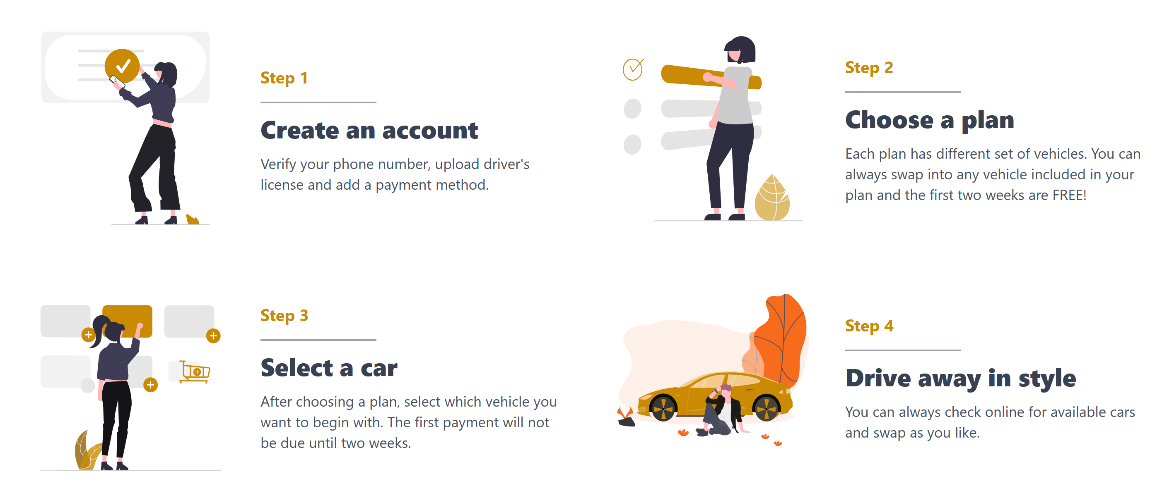

1. Step one will change the add payment method will be deleted.
2. Step 2 will delete and the 1st 2 weeks are free.
3. Step 3 will delete The First payment will not be due until 2 weeks.
4. Step 4 will remain.